Viren Mody

CS 522

HW#3

Due: November 21, 2017

**Part B: Fitts’s Law Replication**

For this assignment, you will be replicating Fitts’s law experiment for aimed movement in graphical user interfaces (GUI). You will need to build the experimental apparatus before collecting and analyzing data. Developing an application for this experiment is **required**.

1. **Describe Fitts’s Law (Fitts’s 1954).**

Paul Fitts’s, in 1954, established Fitts’s Law in a paper that basically models a type of human movement, specifically a model for pointing to objects. It basically is a model that predicts the amount of time it will take a subject to point to a specified target. “This scientific law predicts that the time required to rapidly move to a target area is a function of the ratio between the distance to the target and the width of the target,” (Wikipedia, <https://en.wikipedia.org/wiki/Fitts%27s_law>). ** According to Wikipedia, the following are the parts of Paul Fitts’s model formulation for human movement for pointing.

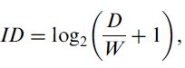

**Index of difficulty:**

where ***ID*** is the index of difficulty, ***D*** is the distance of the pointer’s current position to the target, and ***W*** is the width of the target. The formula on the left is Fitts’s index of difficulty and the one on the right is Shannon’s formulation for index of difficulty.

**Index of performance (throughput):**

where ***IP*** is the index of performance (throughput), ***ID*** is the index of difficult as shown above, and ***MT*** is the movement time it takes the user to point to the target. Most importantly, is the movement time model shown below:

**Movement time:**

where ***MT*** is the average movement time, ***ID*** is the index of difficulty, ***b*** and ***a*** are the slope and intercept parameters respectively which are obtained using linear regression.

Based on Fitts’s Law, an important deduction is that as a target’s width increases and as the distance between serial targets decreases, the index of difficulty and movement time both decrease.

1. **Conduct and report a Fitts’s law experiment for aimed movement.**

**Deliverables:** Application source code and data dump are available at:

<https://github.com/VirenMody/Fitts-Law-Replication>

**Developing the experimental apparatus (app):**

* 1. Input Modality: Mouse
  2. Number of Users: 2
  3. Target Shape: Circle
  4. Number of Targets: 16
  5. Independent Variables
     1. Target width (2): 35 pixels, 55 pixels
     2. Amplitude (3): 200 pixels, 400 pixels, 600 pixels
     3. 6 Cases:With the two above parameters, there are 6 cases (permutations). The order in which these cases were presented to the user were randomized.
  6. Dependent Variables:
     1. Movement time
     2. Throughput/Index of performance
  7. Fitts’s Law
     1. Shannon Formulation for index of difficulty
  8. Programming language: Python
  9. Apparatus design:

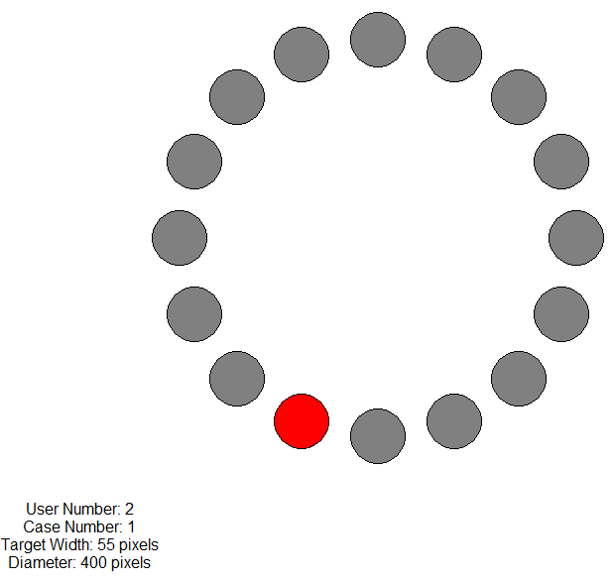

**Data collection:**

1. Data to be collected:
   * 1. Movement time (seconds)
2. Data to be calculated:
   * 1. Index of difficulty (bits)
     2. Throughput/Index of Performance (bits per second)
     3. Average movement times per index of difficulty (6)
     4. Average throughput per index of difficulty (6)

**Data analysis:**

1. Regression coefficients for movement time over index of difficulty:
   1. Slope (b): 0.19098503
   2. Intercept (a): 0.196570520709
   3. Movement time model:
   4. Plot Movement Time over Index of Difficulty.

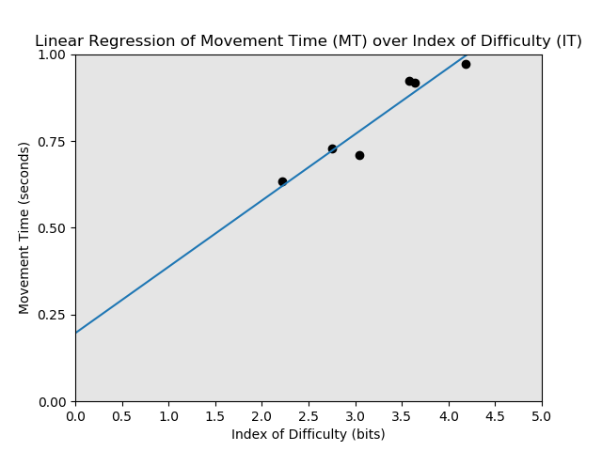

1. Regression coefficients for throughput over index of difficulty:
   1. Slope (b): 0.34882229
   2. Intercept (a): 2.96127940425
   3. Throughput model:
   4. Plot Throughput over Index of Difficulty.

